Projection in a Triangle
# Source: AI Source: Provided by: [Data Path: Persons Table -> ID Column: 1, Name_En Column: Motasem Essam] -> From: [ChatGPT] on [7/25/2026]
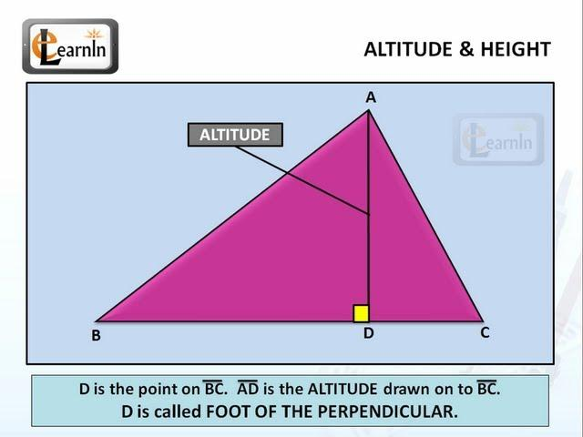
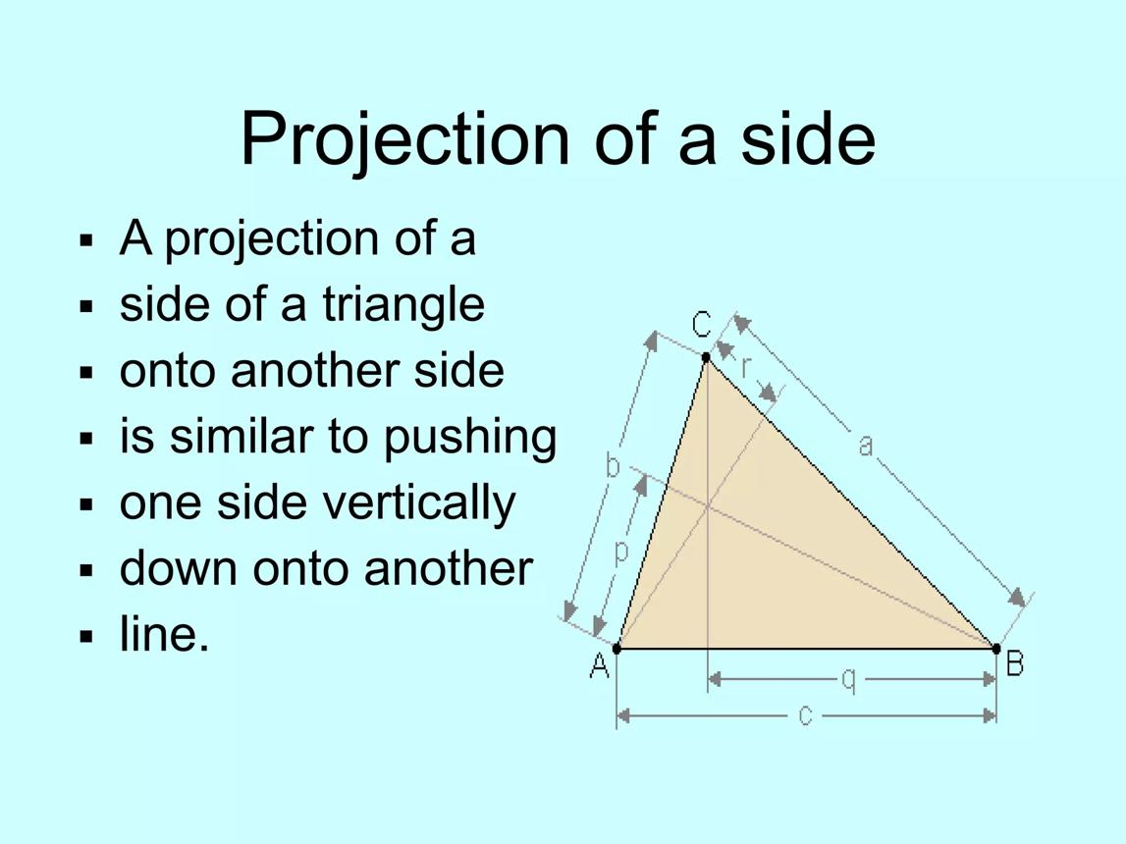
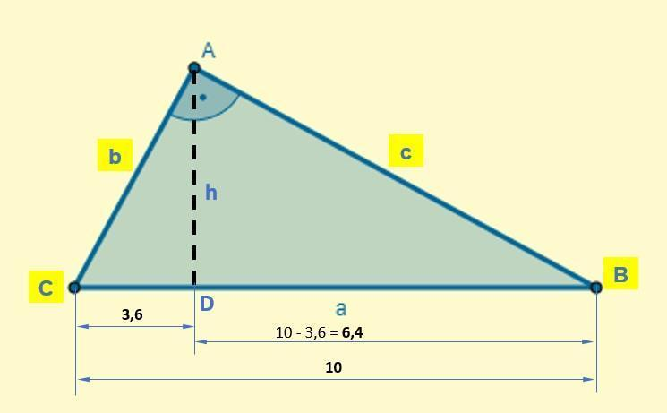

Definition
# Source: AI Source: Provided by: [Data Path: Persons Table -> ID Column: 1, Name_En Column: Motasem Essam] -> From: [ChatGPT] on [7/25/2026]
Projection in a triangle is the process of projecting a point, side, or segment of a triangle onto another side or its extension, usually along a perpendicular direction.
The most common case is the orthogonal projection of a vertex onto the opposite side.
For triangle $ABC$, if the perpendicular from $A$ meets $BC$ at $D$, then $D$ is the orthogonal projection of $A$ onto $BC$:
$$AD⟂BC$$
Here:
- $A$ → original point
- $BC$ → target side
- $D$ → projection point (foot of the perpendicular)
- $AD$ → perpendicular projection
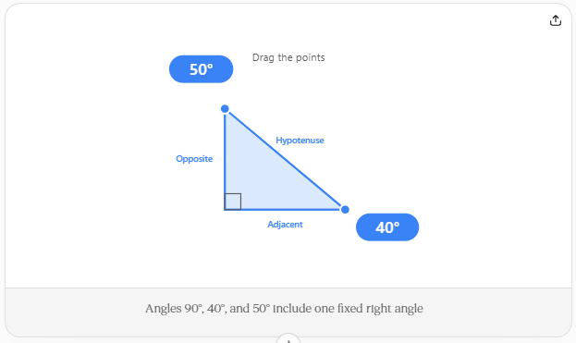
Angles 90°, 40°, and 50° include one fixed right angle
Drag either highlighted vertex to reshape the right triangle. Side labels for adjacent, opposite, and hypotenuse update automatically.
Give feedback

Purpose
# Source: AI Source: Provided by: [Data Path: Persons Table -> ID Column: 1, Name_En Column: Motasem Essam] -> From: [ChatGPT] on [7/25/2026]
Projection in a triangle is useful for:
- Finding heights and altitudes
- Breaking a triangle into right triangles
- Finding unknown side lengths
- Applying the Pythagorean Theorem
- Using trigonometric functions
- Finding the components of a side
- Calculating distances
- Studying geometric relationships

1. Projection of a Vertex onto the Opposite Side
# Source: AI Source: Provided by: [Data Path: Persons Table -> ID Column: 1, Name_En Column: Motasem Essam] -> From: [ChatGPT] on [7/25/2026]
Consider triangle $ABC$.
Draw a perpendicular from $A$ to $BC$, meeting $BC$ at $D$.

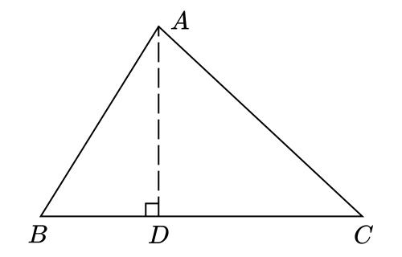
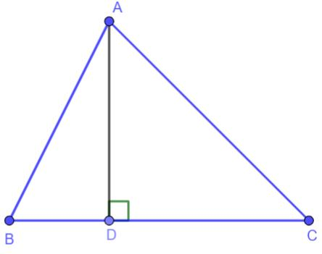
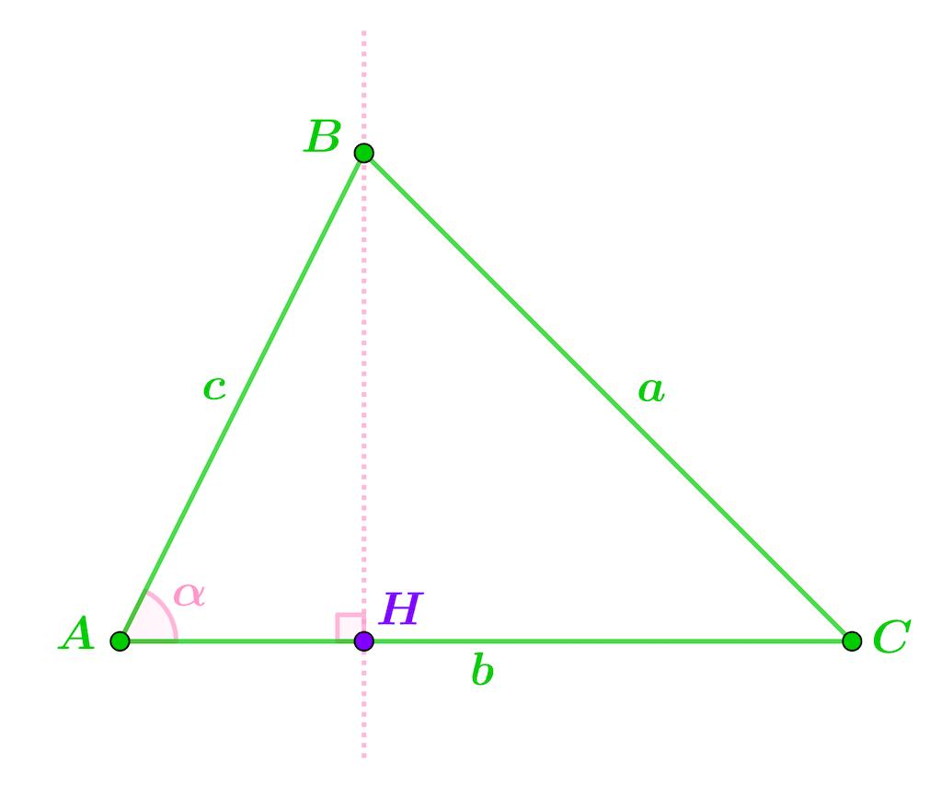
Then:
$$AD⟂BC$$
and $D$ is the projection of $A$ onto $BC$.
The segment $AD$ is also the altitude of triangle $ABC$ relative to base $BC$.
Therefore:
$$\boxed{\text{Projection of }A\text{ onto }BC=D}$$
and
$$\boxed{AD=\text{altitude}}$$

2. Projection Length of a Side
# Source: AI Source: Provided by: [Data Path: Persons Table -> ID Column: 1, Name_En Column: Motasem Essam] -> From: [ChatGPT] on [7/25/2026]
Suppose side $AB$ makes an angle $θ$ with side $BC$.
The orthogonal projection of $AB$ onto $BC$ is the portion of $BC$ corresponding to $AB$.
If the projection has length $BD$, then:
$$cosθ=\frac{BD}{AB}$$
Therefore:
$$\boxed{BD=ABcosθ}$$
For an acute angle $0^{∘}≤θ≤{90}^{∘}$.
Example
Suppose:
$$AB=10$$
and
$$θ={60}^{∘}$$
Then:
$BD=10cos{60}^{∘}$ $BD=10\left(\frac{1}{2}\right)$ $\boxed{BD=5}$

3. Projection and the Altitude of a Triangle
# Source: AI Source: Provided by: [Data Path: Persons Table -> ID Column: 1, Name_En Column: Motasem Essam] -> From: [ChatGPT] on [7/25/2026]
Projection is directly connected to the altitude.
If $AD$ is perpendicular to $BC$:
$$AD⟂BC$$
then $AD$ is the altitude from $A$.
This creates two right triangles:
$$△ABD$$
and
$$△ACD$$
Therefore, projection can transform a general triangle into simpler right triangles.

4. Projection in an Acute Triangle
# Source: AI Source: Provided by: [Data Path: Persons Table -> ID Column: 1, Name_En Column: Motasem Essam] -> From: [ChatGPT] on [7/25/2026]
In an acute triangle, the perpendicular from each vertex to the opposite side falls inside the triangle.

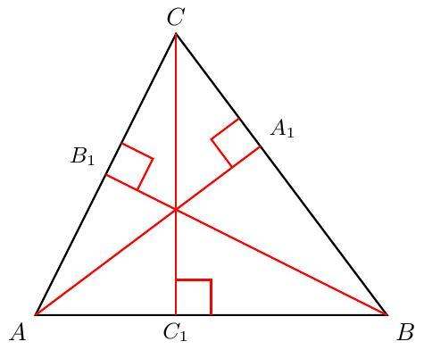
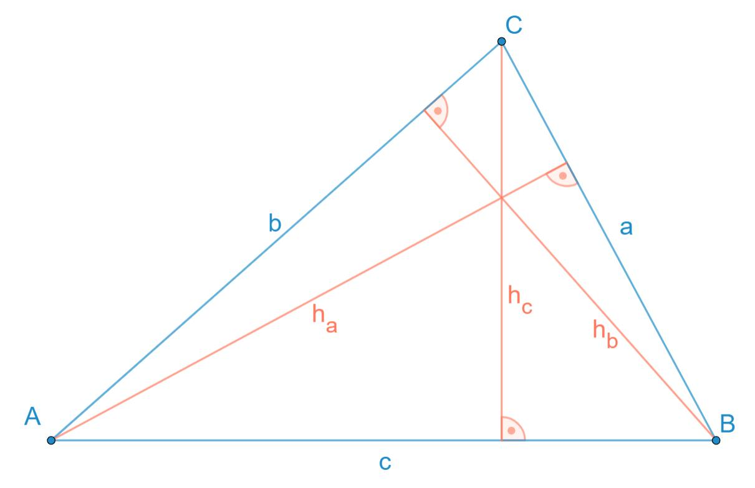
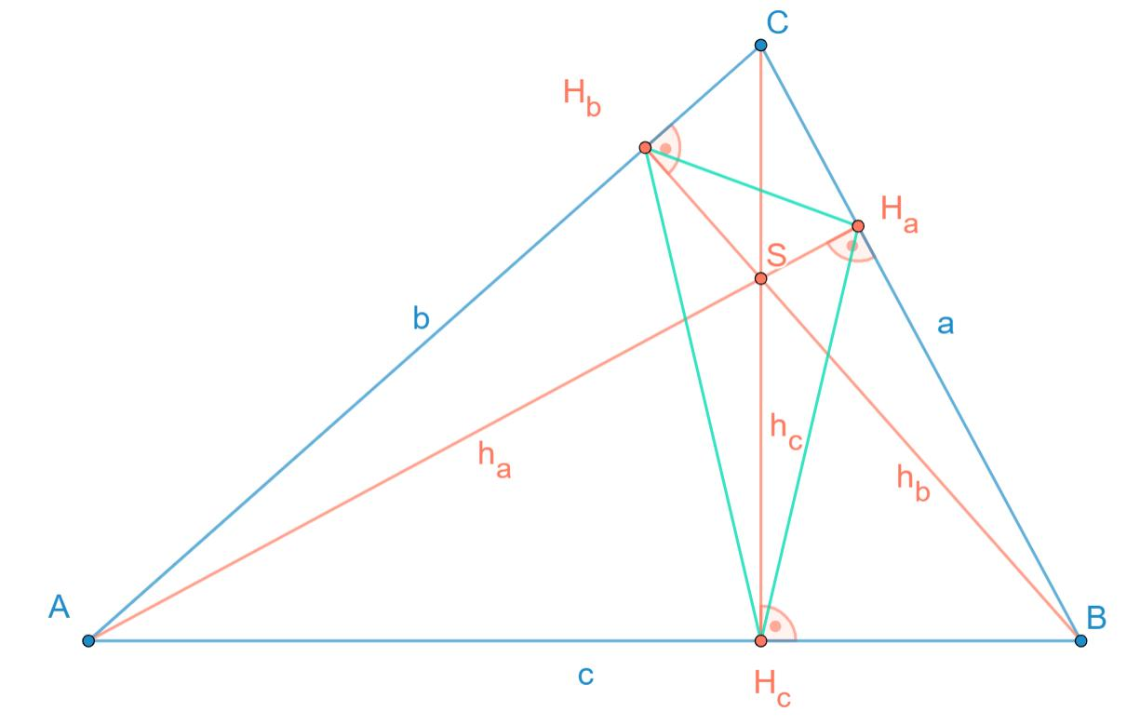
For example:
$$AD⟂BC$$
with $D$ located between $B$ and $C$.
Similarly, projections from $B$ and $C$ onto their opposite sides also fall inside the triangle.

5. Projection in a Right Triangle
# Source: AI Source: Provided by: [Data Path: Persons Table -> ID Column: 1, Name_En Column: Motasem Essam] -> From: [ChatGPT] on [7/25/2026]
Consider right triangle $ABC$, where:
$$∠A={90}^{∘}$$
The altitude from $A$ to hypotenuse $BC$ meets $BC$ at $D$.

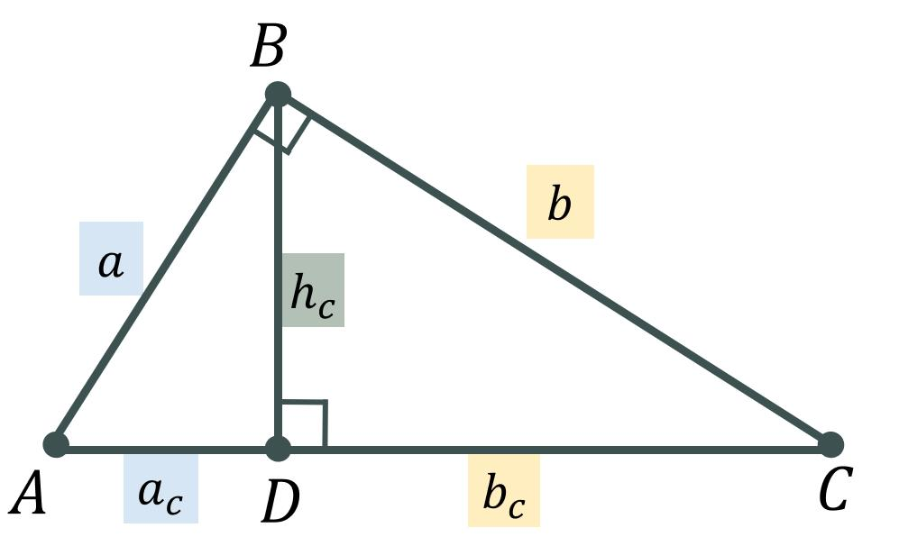
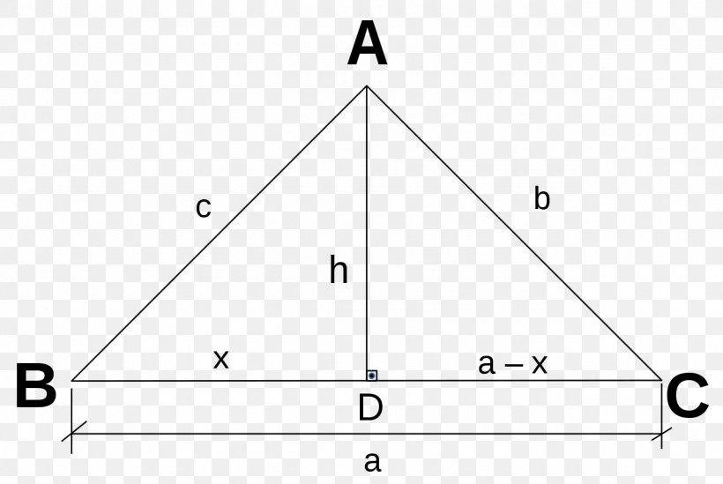
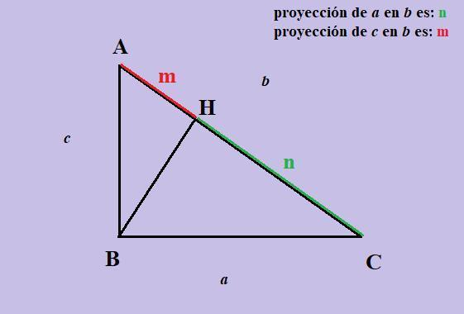
Then:
$$AD⟂BC$$
The hypotenuse is divided into two projection segments:
$$BD$$
and
$$DC$$
These projections have important relationships with the sides.
For example, the geometric mean relationships are:
$AB^{2}=BD⋅BC$ $AC^{2}=DC⋅BC$
and the altitude satisfies:
$$AD^{2}=BD⋅DC$$
These are commonly known as Euclid's theorems in right triangles.

6. Projection in an Obtuse Triangle
# Source: AI Source: Provided by: [Data Path: Persons Table -> ID Column: 1, Name_En Column: Motasem Essam] -> From: [ChatGPT] on [7/25/2026]
In an obtuse triangle, the perpendicular projection of a vertex can fall outside the triangle.

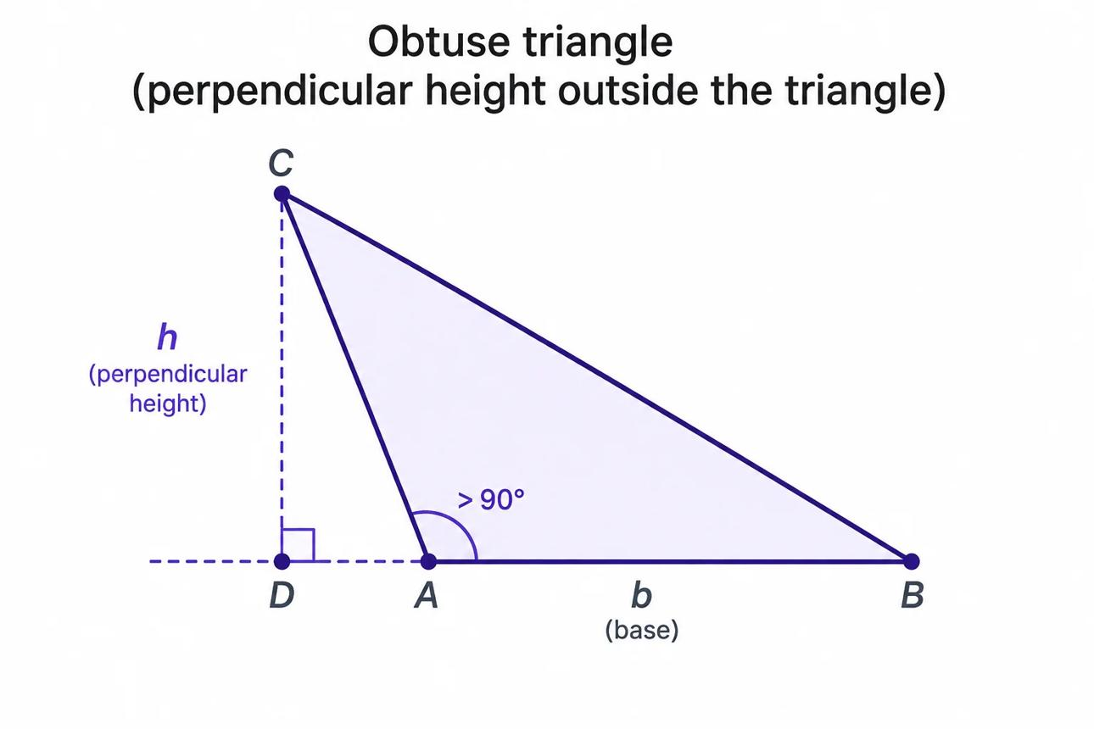
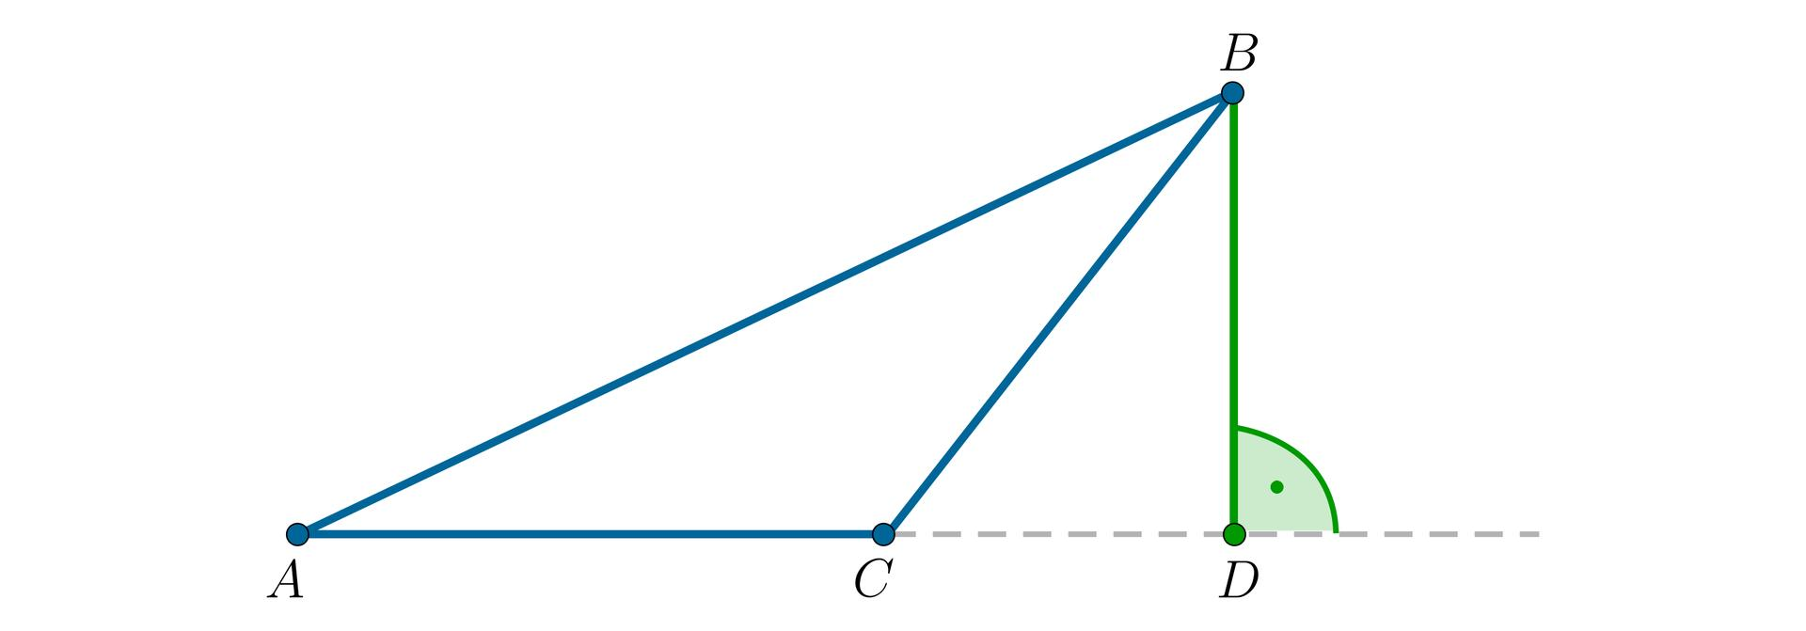
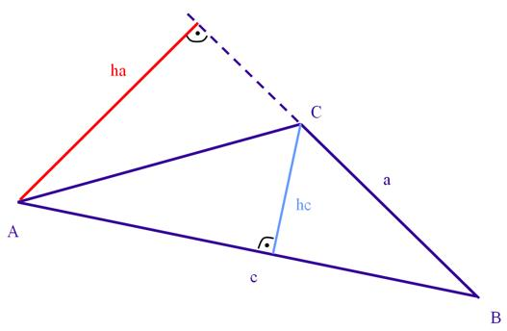
For example, if $A$ is the obtuse vertex, the perpendicular from another vertex may meet the extension of the opposite side.
The projection is still valid because the target is considered to be the line containing the side, not necessarily only the finite segment.

7. Projection Using Trigonometry
# Source: AI Source: Provided by: [Data Path: Persons Table -> ID Column: 1, Name_En Column: Motasem Essam] -> From: [ChatGPT] on [7/25/2026]
Projection is closely related to cosine.
For a segment of length $L$ making an angle $θ$ with the target line:
$$\boxed{L_{\text{projection}}=Lcosθ}$$
For an orthogonal projection, the magnitude is often written:
$$\boxed{L_{\text{projection}}=L|cosθ|}$$
The absolute value is useful when the direction of the projection is considered.
Example
A side has length:
$$AB=12$$
and makes an angle:
$$θ={30}^{∘}$$
with the target side.
Then:
$AB_{\text{projection}}=12cos{30}^{∘}$ $=12\left(\frac{\sqrt{3}}{2}\right)$ $\boxed{AB_{\text{projection}}=6\sqrt{3}}$

8. Coordinate Geometry
# Source: AI Source: Provided by: [Data Path: Persons Table -> ID Column: 1, Name_En Column: Motasem Essam] -> From: [ChatGPT] on [7/25/2026]
Projection can also be used in coordinate geometry.
Suppose:
$$A=(2,5)$$
and:
$$B=(8,9)$$
The projection onto the $x$-axis is:
$A^{'}=(2,0)$ $B^{'}=(8,0)$
Therefore:
$A^{'}B^{'}=|8-2|$ $\boxed{A^{'}B^{'}=6}$
The vertical coordinates disappear because the projection is onto the $x$-axis.

9. Projection of the Three Sides
# Source: AI Source: Provided by: [Data Path: Persons Table -> ID Column: 1, Name_En Column: Motasem Essam] -> From: [ChatGPT] on [7/25/2026]
Each side of a triangle can be projected onto another side or its extension.
For example, projecting $AB$ onto $BC$:
$${proj}_{BC}(AB)$$
Projecting $AC$ onto $BC$:
$${proj}_{BC}(AC)$$
The resulting projected lengths depend on the angles between the sides.

10. Important Special Cases

Side parallel to the target
# Source: AI Source: Provided by: [Data Path: Persons Table -> ID Column: 1, Name_En Column: Motasem Essam] -> From: [ChatGPT] on [7/25/2026]
If:
$$θ=0^{∘}$$
then:
$$L_{\text{projection}}=Lcos0^{∘}=L$$
So the projection has the same length.

Side perpendicular to the target
# Source: AI Source: Provided by: [Data Path: Persons Table -> ID Column: 1, Name_En Column: Motasem Essam] -> From: [ChatGPT] on [7/25/2026]
If:
$$θ={90}^{∘}$$
then:
$$L_{\text{projection}}=Lcos{90}^{∘}=0$$
So the entire segment projects onto a single point.

Side at ${60}^{∘}$
# Source: AI Source: Provided by: [Data Path: Persons Table -> ID Column: 1, Name_En Column: Motasem Essam] -> From: [ChatGPT] on [7/25/2026]
$L_{\text{projection}}=Lcos{60}^{∘}$ $=\frac{L}{2}$
So the projection is half the original length.

11. Projection and the Pythagorean Theorem
# Source: AI Source: Provided by: [Data Path: Persons Table -> ID Column: 1, Name_En Column: Motasem Essam] -> From: [ChatGPT] on [7/25/2026]
Projection often creates right triangles.
Suppose $AD$ is perpendicular to $BC$.
Then:
$$△ABD$$
is a right triangle, so:
$$AB^{2}=AD^{2}+BD^{2}$$
Similarly:
$$AC^{2}=AD^{2}+DC^{2}$$
Thus projection provides a way to apply the Pythagorean Theorem to a non-right triangle.

12. Projection and Triangle Area
# Source: AI Source: Provided by: [Data Path: Persons Table -> ID Column: 1, Name_En Column: Motasem Essam] -> From: [ChatGPT] on [7/25/2026]
The altitude obtained by projection is essential for calculating the area of a triangle.
If $AD$ is the altitude to base $BC$:
$$AD⟂BC$$
then:
$$\boxed{A=\frac{1}{2}(BC)(AD)}$$
or:
$$\boxed{A=\frac{1}{2}bh}$$
where:
- $b$ = base
- $h$ = perpendicular height
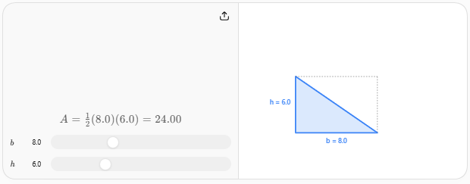
Example
If:
$$BC=10$$
and:
$$AD=6$$
then:
$A=\frac{1}{2}(10)(6)$ $\boxed{A=30}$

13. Vector Projection
# Source: AI Source: Provided by: [Data Path: Persons Table -> ID Column: 1, Name_En Column: Motasem Essam] -> From: [ChatGPT] on [7/25/2026]
Projection can also be expressed using vectors.
If $\vec{AB}$ is projected onto a direction vector $\vec{u}$, then:
$$\boxed{{proj}_{\vec{u}}\vec{AB}=\frac{\vec{AB}⋅\vec{u}}{∥\vec{u}∥^{2}}\vec{u}}$$
If $\vec{u}$ is a unit vector:
$$\boxed{{proj}_{\vec{u}}\vec{AB}=(\vec{AB}⋅\vec{u})\vec{u}}$$
The scalar projection is:
$$\boxed{\vec{AB}⋅\vec{u}}$$
when $\vec{u}$ is a unit vector.

14. Projection vs. Altitude
# Source: AI Source: Provided by: [Data Path: Persons Table -> ID Column: 1, Name_En Column: Motasem Essam] -> From: [ChatGPT] on [7/25/2026]
These concepts are closely related but are not exactly the same.
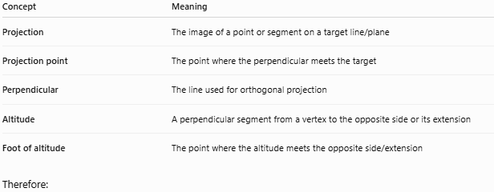
Concept | Meaning
Projection | The image of a point or segment on a target line/plane
Projection point | The point where the perpendicular meets the target
Perpendicular | The line used for orthogonal projection
Altitude | A perpendicular segment from a vertex to the opposite side or its extension
Foot of altitude | The point where the altitude meets the opposite side/extension
Therefore:
$$\boxed{\text{An altitude is a special case of perpendicular projection}}$$

15. Projection vs. Side
# Source: AI Source: Provided by: [Data Path: Persons Table -> ID Column: 1, Name_En Column: Motasem Essam] -> From: [ChatGPT] on [7/25/2026]
A triangle side and its projection are not necessarily the same length.
If a side $AB$ is projected onto $BC$:
$$AB_{\text{projection}}=AB|cosθ|$$
Therefore:
$$AB_{\text{projection}}≤AB$$
Equality occurs only when:
$$θ=0^{∘}$$

Properties
# Source: AI Source: Provided by: [Data Path: Persons Table -> ID Column: 1, Name_En Column: Motasem Essam] -> From: [ChatGPT] on [7/25/2026]
- Orthogonal projection uses a perpendicular direction.
- The projection of a point is a single point.
- The projection of a segment is generally a segment.
- A perpendicular segment can project to a point.
- A segment parallel to the target preserves its length.
- Projection length cannot exceed the original segment length.
- Projection is closely related to triangle altitudes.
- Projection can create right triangles.
- Projection is useful with trigonometry and the Pythagorean Theorem.
- The projection can lie outside the triangle in an obtuse triangle.

Common Mistakes

Mistake 1: Confusing projection with altitude
# Source: AI Source: Provided by: [Data Path: Persons Table -> ID Column: 1, Name_En Column: Motasem Essam] -> From: [ChatGPT] on [7/25/2026]
Not every projection is an altitude.
An altitude specifically starts at a triangle vertex and is perpendicular to the opposite side or its extension.

Mistake 2: Forgetting the side extension
# Source: AI Source: Provided by: [Data Path: Persons Table -> ID Column: 1, Name_En Column: Motasem Essam] -> From: [ChatGPT] on [7/25/2026]
In an obtuse triangle, the projection may lie outside the triangle.

Mistake 3: Using sine instead of cosine
# Source: AI Source: Provided by: [Data Path: Persons Table -> ID Column: 1, Name_En Column: Motasem Essam] -> From: [ChatGPT] on [7/25/2026]
For the projection of a segment onto the direction with which it makes angle $θ$:
$$\boxed{L_{\text{projection}}=Lcosθ}$$
The cosine gives the component along the target direction.

Comparison with Related Concepts
# Source: AI Source: Provided by: [Data Path: Persons Table -> ID Column: 1, Name_En Column: Motasem Essam] -> From: [ChatGPT] on [7/25/2026]
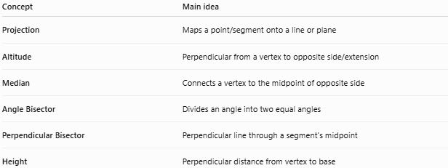
Concept | Main idea
Projection | Maps a point/segment onto a line or plane
Altitude | Perpendicular from a vertex to opposite side/extension
Median | Connects a vertex to the midpoint of opposite side
Angle Bisector | Divides an angle into two equal angles
Perpendicular Bisector | Perpendicular line through a segment's midpoint
Height | Perpendicular distance from vertex to base

Applications
# Source: AI Source: Provided by: [Data Path: Persons Table -> ID Column: 1, Name_En Column: Motasem Essam] -> From: [ChatGPT] on [7/25/2026]
Projection in triangles is used in:
- Trigonometry
- Coordinate geometry
- Vector mathematics
- Engineering
- Architecture
- Physics
- Computer graphics
- Surveying
- Navigation
- 3D geometry
For example, in physics, a force can be separated into components parallel and perpendicular to a surface using projection.

Key Points
# Source: AI Source: Provided by: [Data Path: Persons Table -> ID Column: 1, Name_En Column: Motasem Essam] -> From: [ChatGPT] on [7/25/2026]
- Projection places a geometric object onto another line or plane.
- In triangles, the most important projection is the orthogonal projection.
- If $AD⟂BC$, then $D$ is the projection of $A$ onto $BC$.
- $AD$ is also the altitude from $A$.
- Projection length is determined using cosine:
$$\boxed{L_{\text{projection}}=L|cosθ|}$$
- Projection is fundamental to triangle area, trigonometry, vectors, and right-triangle relationships.
- In obtuse triangles, a projection may fall outside the triangle.

Conclusion
# Source: AI Source: Provided by: [Data Path: Persons Table -> ID Column: 1, Name_En Column: Motasem Essam] -> From: [ChatGPT] on [7/25/2026]
Projection in a triangle is the perpendicular mapping of a point or segment onto a side or the line containing that side. Its most important application is the relationship between projection, altitude, right triangles, cosine, and the Pythagorean Theorem.
$$\boxed{\text{Projection}→\text{Perpendicular foot}→\text{Right triangle relationships}}$$

